REPORT
Mentor from Norway: Eva Sognebotten (Labour Party)
Mentee: Magdalena Pospíchalová
23-25th February 2016
Norway

Wednesday 24th of February

Meeting in the Crisis Center in Hamar - this center is regional shelter for women, men and children who experience violence and assault in their homes. There are different types of such violations (physical, psychological, sexual, material, financial etc). This house can accommodate 50 people. There are 8 rooms and one special flat with a separate entrance for men or for those who are ready to come home, so they could be more independent on the services of the asylum. Such shelters were originally non-governmental institution but nowadays there transformed under the state administration. In this center there are 15 social workers with the social, psychological, educational, anthropology background and also 3 or 4 volunteers (for example students of psychology or sociology). Among clients there are 40 – 60% of immigrants which indicates that the integration program for them is effective even among these people and also they had last year two men clients with children. The Crisis Center cooperates a lot with police and other social institutions.
It was very nice place with pleasant atmosphere.

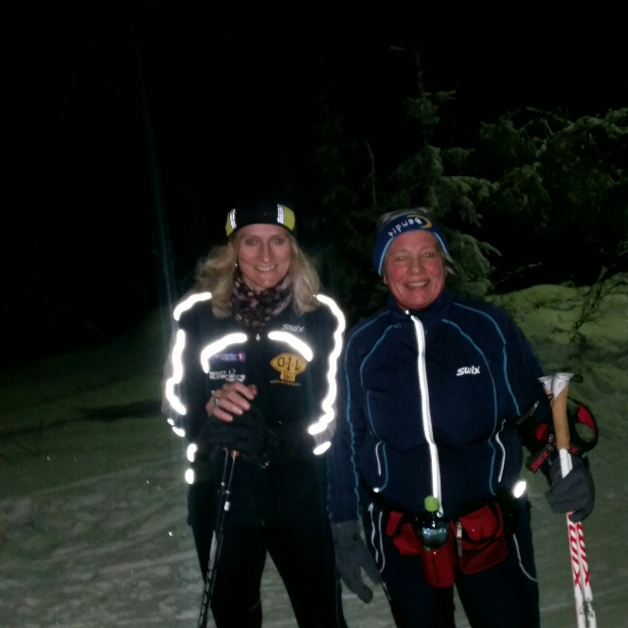
Planning Administration in the Municipality of Stange – meeting with the cheef of the Department of Planning in which Eva Søgnebotten is the political head. We were introduced to all officers and their competence. It was interesting how open and friendly they were to each other.

In the evening - Cross-country skiing in 20km far Ski resort

Thursday 25th of February
- Press Conference at Hamar at the railway station. Subject – Financing of the regional road project. Representatives of local municipalities, which are involved in this project.
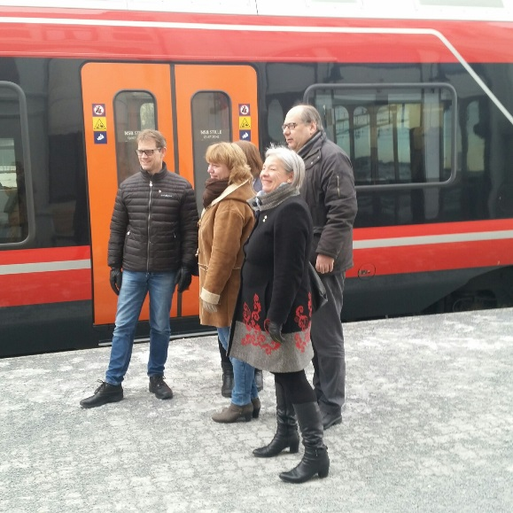

- Lunch – together with mentor cup Hilde Thorkildsen and Dita Výborová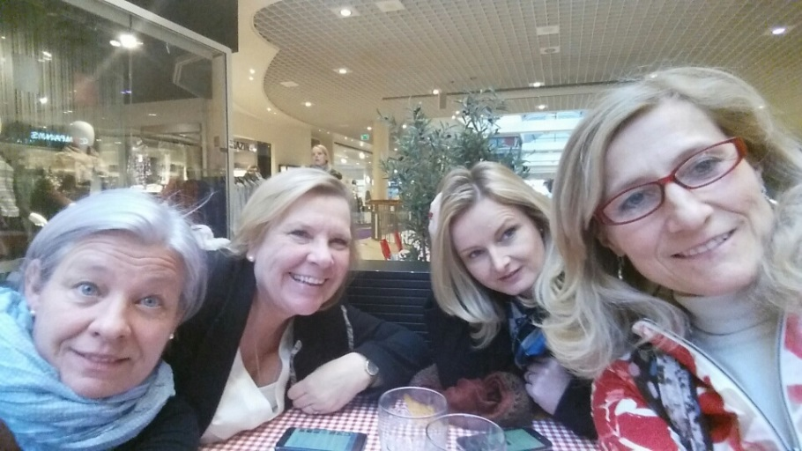

- Meeting at the Department: Equality and Anti-Discrimination Ombudsman in Oslo

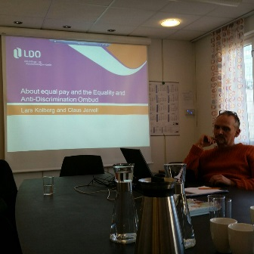
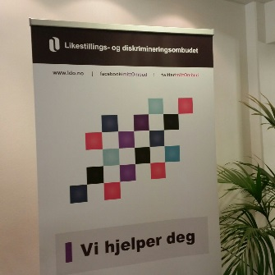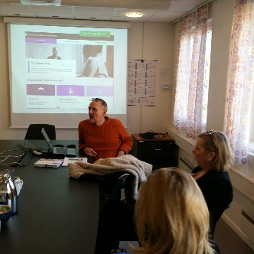

This office is subordinated to the Ministry of Children and Equality but as an independent administrative agency. The Ombudswoman Hanne Inger Bjurstrøm shall uphold the law and promote equality in all areas of society by: making determinations, providing information – legal rights and responsibilities, providing Surveys and identifying trends, providing employers with information/guidance, serving as a Forum and information center.
We got a presentation from Lars Kolberg and Claus Jervell
We were talking about part-time job problems, which is nowadays opposite problem then we have here and there is another approach in society: so called “full time culture”. Because part-time caused problems in some sectors mainly in health care and also in pension system.
We also spoke about big role of trade union in wages agreements in public as well as private sector.
Here you have interesting data linked to the gender pay gap, which was another topic we spoke about.
http://www.ssb.no/en/befolkning/nokkeltall/key-figures-on-gender-equality

