We can do it! Empowering women, challenging conservative backlash and combating gender stereotypes in the Czech Republic
Jana Smiggels Kavková, Veronika Šprincová

1. Where are we? Gender (in)equality in the Czech Republic
According to the latest Global Gender Gap Report (World Economic Forum – WEF) mapping four fundamental categories – economic participation and opportunity, educational attainment, health and survival and political empowerment - the Czech Republic occupies 83rd place out of 136. In the last years its place is constantly in the middle of the ranking; in 2012 it occupied 73rd place signalizing that the progress in monitored categories in the other countries is faster than in the Czech Republic. In the following part of the paper we will present the data linked to the two main areas – political empowerment and situation of women in the labour market.
The underrepresentation of women in decision-making seems to be the crucial issue having a direct negative impact on women’s rights and opportunities in general. According to the Constitution and law women and men have equal rights. However, inequalities in public and economic life still exist.
1.2. Political participation of women
Regarding the representation of women in all important political bodies in the world and particularly Europe, the Czech Republic falls under the average. At the same time, the situation is in some aspects ironic – e.g. in 2010 the historically highest number of women deputies (22%) was elected. Nevertheless the national government was assembled as men-only. The first women (non-ministerial position) was appointed only one year after government’s appointment.
Following the 2013 elections, there are 19.5% women represented in the Chamber of Deputies (Lower House). The proportion of women in the Senate (Upper House) is lower – 17.3%.
Chart No. 1: Representation of women amongst the nominated and elected candidates to the Chamber of Deputies from 1996 to 2013
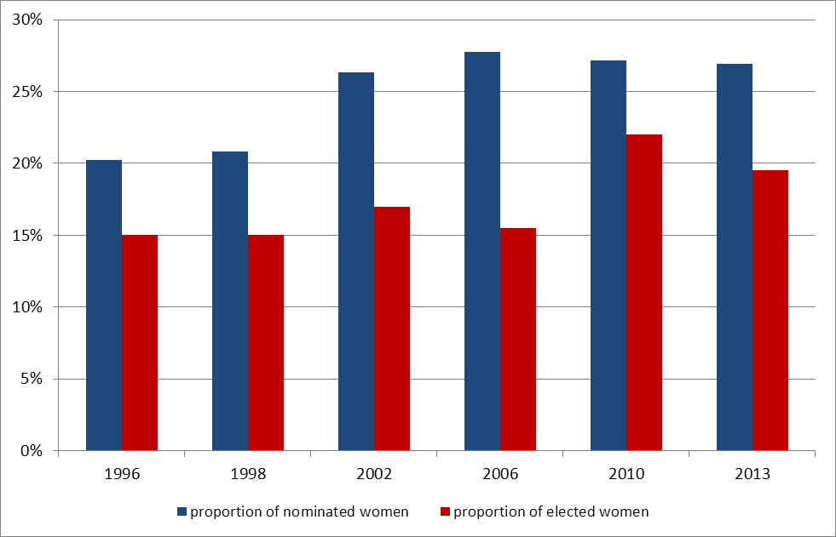
Data source: Czech Statistical Office
As indicated in the Chart No.2, due to majority rule voting system less women have been represented in the Senate compared to the Chamber of Deputies over the monitored period of time. Furthermore in both houses the development is not linear.
Chart No. 2: Elected female candidates to the Chamber of Deputies and the Senate from 1996 until 2013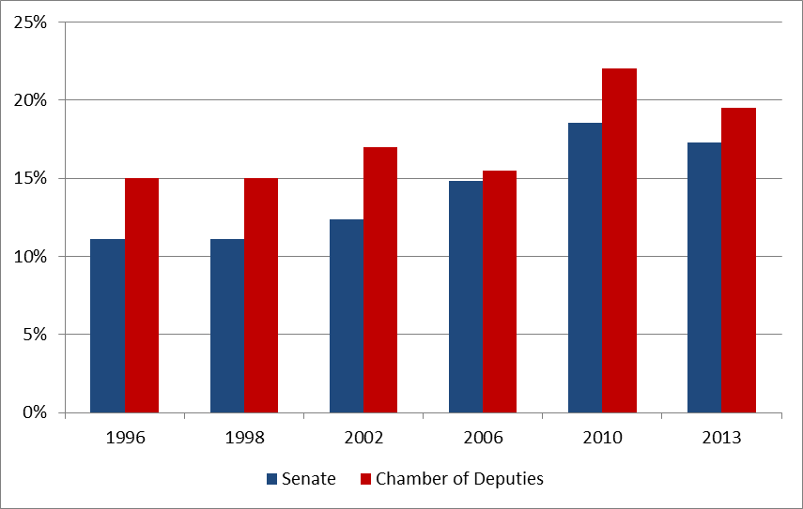
Data source: Czech Statistical Office
Lately, the representation of women in the governments varied following frequent personnel changes. Therefore, the composition of the government from the gender perspective has kept changing during its term of office. From this point of view the government of the Prime Minister Petr Nečas illustrates situation described above. In July 2010, there was an exclusively male cabinet appointed, three years later upon its resignation followed by a government formed from almost 19 % by women.
Presence of women in the Czech governments to some extend resembles a general, often chaotic Czech political situation, especially in the top echelons of politics. Similarly to the Parliament of the Czech Republic, the development of women’s representation in the government was not linear (see Chart no. 3). Moreover, there is no evident correlation between women representation and the fact that the government is either political, or caretaker (as there have been 3 caretaker governments appointed since 1992).
Chart No. 3: Development of women representation in the Government of the Czech Republic from 1992 to 2013
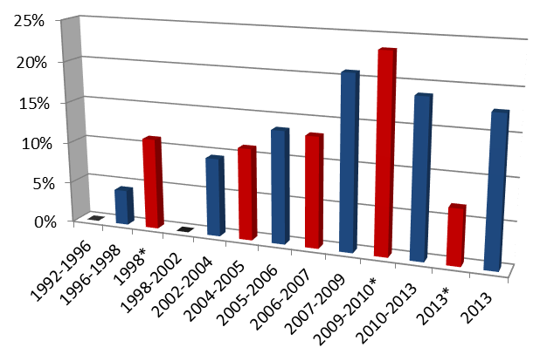
*caretaker government
Data source: The official website of the Government of the Czech Republic (www.vlada.cz)

Women’s representation is slightly higher in the regional and local governments. However, the percentage on neither level reaches the critical 30% benchmark.
Women have to face many kind of barriers preventing them from succeeding and entering politics as easy as men. Barriers persist on individual (lack of self-confidence, responsibility for kids and family) and structural (patriarchal model of the family, gender stereotypes etc.) level. The strongest barriers are within the political parties where women are present in the member base but excluded from the leadership (glass ceiling). Only one of the Czech political parties (Green Party) is using quotas for assembling the ballots. Women have only little chances to influence the most crucial decisions within political parties, such as political programmes etc.

2. Women in the Labour Market
Gender inequalities remain also in the labour market. Despite majority of women among university graduates (61% women; even in fields like economy – 66% women graduates), according to WEF their economic participation and opportunity is compared to men unequal. Decision-making positions can serve as illustrative example of so called glass ceiling. According to McKinesy&Company women’s representation in executive committees and company boards is 8 % without a signal of any development (positive or negative); the Deloitte study shows that among 100 biggest companies in the Czech Republic there are only 7.6 % women in their boards.
Besides vertical segregation, horizontal segregation of the labour market is also apparent. “Feminised” branches such as social work, health care or primary and secondary education are less paid than those where men prevail (engineering, industry, finance). Even though women compose majority among university graduates, gender inequalities persists in tertiary education and academia in general copying the situation in the labour market in general.
The gender pay gap is above the EU average – 24.1%. As indicated in previous paragraph, splitting of “typically men's and women's branches” still persists and is closely connected to existing gender stereotypes. The biggest issue in this area is work-life balance.
Complex strategy and state support have been missing for years. The situation could be well described by former PM Mirek Topolánek’s statement. He proclaimed that „a woman can freely choose not to have children and then in such a case I am sure that she has the same job opportunities like a man.“ Mother's working activity with her children until their age of three has been influenced with insufficient supply of public childcare.
The last right-wing and conservative governments (in office between 2006 and 2013) efficiently blocked any effort leading to a positive change. The current coalition government (socialists, Christian democrats and rather centrist movement ANO 2011) appointed in January 2014 proclaim the will to improve the situation of women and to prepare relevant state policy focused mainly on work-life balance. No complex strategy or policy have been introduced yet. There is one positive shift that needs to be mentioned: the position of Czech government regarding the EC directive regarding women on boards has changed radically from total disapproval of the previous government to the supportive attitude of the current one.
2. What are the biggest issues related to gender equality?
As mentioned above, the underrepresentation of women in decision-making both in politics and business sector are serious problems. Systematic approach to solve the situation is missing. Positive measures are denied as “limiting free competition” by many politicians and opinion makers although no alternative suggestions were offered do far. Besides inequalities in politics and labour market, the area of women's reproductive rights and violence against women represent other burning issues. Persisting gender stereotypes and unequal distribution of power across different social spheres are the core problem.
Even though the “traditional” family model is not very frequent, women are still more or less perceived as caretakers and men as breadwinners. Single mothers are one of the social groups most endangered by poverty. Living elderly women are another of these groups. Women are also usually responsible for the household and childcare (and in case of single living women also for financial security). The austerity measures and other reforms implemented by previous government (especially between 2010 and 2013) deepened the gender inequalities, weakened the whole gender equality agenda and its institutional safeguarding.
Women are limited in their free choice of their place of childbirth in the Czech Republic denying all decisions made by the European Court of Human Rights. The Ministry of Health's actions ignores scientific findings about what the safe childbirth really means. Many redundant medical examinations into which the expectant mothers are forced have also been a part of common Czech practice.
Midwifes assisting home childbirths are prosecuted. There was a big case concerning the most famous Czech midwife Ivana Königsmarková. After a home childbirth a baby died in the hospital after a few days and she was accused for being responsible for this situation (she was accused by the hospital, not by the parents). Königsmarková was found guilty by the court, imposed the penalty of 2 000 000 Czech crowns and banned from practising her profession. The result of the court was much stricter compared to similar cases that happened in hospitals. Moreover, the lawsuit did not follow standard process and did not take into account expert evidences speaking in favour of the midwife. At the end, the Constitutional Court revoked the verdict.
Gender based violence is still not sufficiently reflected by state policies – the term “domestic violence” is used (embracing violence against women, children as well as men) ignoring the fact that the term violence against women points out the gender context of the violent behaviour no matter whether it's sexual or home violence. Although 86 % of victims of sexual abuse were women (1140 persons in all); 38 % of women experienced some of the forms of violence of their partners in 2010, Nečas government refused to sign convention of the Council of Europe concerning violence against women, the so called Istanbul treaty. The new government is fortunately changing this attitude and the ratification of the Istanbul treaty is planned.
3. What has been done so far?
3.1. Role of the state and political parties
The current political representation appears to be more favourable to advancing gender issues compared to previous conservative cabinets. Between 2006 and 2013 the governments did not find equal opportunities of women and men as an important issue. Ministry of Human Rights (responsible also for this issue) was terminated in 2010. After that the institutional support of equal opportunities was restoring very slowly. After strong advocacy efforts of Czech NGOs the post of Minister for human rights and equal opportunities has been restored in January 2014. In spring 2014 the gender equality agenda was transferred back from Ministry of Labour and Social Affairs to the Office of the Government.
For a long time, will or financial support from the state to promote gender equality was lacking contributing to the inconvenient environment for promoting gender issues. On the contrary – part of NGOs' and other experts' time and energy was invested into objecting to government activities and decisions and appealing on international commitments and other strategic documents undertaking the Czech Republic to advance gender equality. The only gender-related issue to some extend recognized by the state (mainly due to EU funds) was work-life balance and domestic violence. In 2013 state fund for financing activities in the field of gender equality was restored after many years.
Positions and strategies of political parties represented in the Chamber of Deputies are annually evaluated by NGO Forum 50 % in the annual award Women Friendly Party. For a long time, the Green Party has been winning the competition due to its respect to gender equality within the party as well as in its political programme. Generally said, conservative or “rightist” parties are not much open to gender issues assuming that men and women already have equal opportunities. The only issue they reflect is work-life balance (e.g. the Civic Democratic Party promotes company nurseries or small home nurseries).
Parties placed on the left side of political spectrum are more gender sensitive while emphasizing the role of the state in achieving equality between women and men. Between 2006 and 2013 no “leftist” party was represented in the government and the gender agenda was blocked. As mentioned above, the current government proclaims these issues to be important. Until now the biggest progress was made in restoring the whole system of institutional structures for equality between women and men. At the same time, the Ministry of the Interior proposed the bill introducing legislative gender quota for assembling ballots. The initiative came from the Minister for human rights and equal opportunities Jiří Dienstbier, who is a strong advocate for quotas. It passed through inter-ministerial consultation process and now the government will discuss it. However, the leader of Christian democrats (one of coalition partners) proclaimed his party will not support the gender quota proposal. The chances that the bill will pass through the Parliament are even lower. Even though the chances of adopting the law are questionable, it is a big step forward. It creates a window of opportunity by bringing the issue of parity of women and men in politics on the political agenda.
Public debate is unfortunately very biased and influenced by the discourse set by conservative governments. The positive change is that some opinion leaders (mostly men) support positive measures and bring relevant arguments into the discussion. This could have positive impact in a long-term perspective.
3.2. Role of the NGOs
In the last years the role of NGOs in this area was principal. It did not cut down on only watchdog activities but it was also the only sector building up methodology and conception in the field of gender equality. Regarding work-life balance, NGOs expertise implemented particular programmes in cooperation with private companies and usually without any (or only with minimal) support from the state.
The current government considers gender equality as an important topic. However, it is still a short time to assess how successfully it fulfils its programme and to what extent it reflects the recommendations of the government Council for equal opportunities of women and men, the experts and NGOs as such. Examples of a good cooperation with non-profit sector at the level of the municipalities and regions could be found under conservative government.
Due to long-term grant policy of the state a lot of organisations directed their attention to work-life balance and they did not have enough human or financial capacity to pursue their original activities and agenda.
Compared to the long-term state's approach, there is a very active and operational non-profit sector. Gender and women's NGOs supplied (and still supply) the role of the state and cooperate together in many areas. The most of them are associated in an umbrella organisation Czech Women's Lobby (there are 28 member organisations today). “Czech Women's Lobby declares its support to feminist belief that women have their right to political, social and economic equality with men. Czech Women’s Lobby lobs and asserts the interests of all women regardless of their race, ethnic origin, health condition, sexual orientation, age, religion or belief. At the same time, CWL promotes diversity and acknowledges and asserts diverse values and needs of women with regard to the above mentioned characteristics. Czech Women’s Lobby accepts variety of its organizations as well as variety of feminist trends professed by individual organizations.” The main issues of the Czech Women's Lobby are: sexuality and reproductive rights of women, prostitution and human trafficking, violence against women, women in decision-making positions, women in labour market and gender roles and stereotypes. CWL is member of European Women´s Lobby, the largest umbrella of women NGO s in Europe.
In 2012 new important initiative emerged – Women’s Congress. It was directly inspired by Polish Women’s Congress and it was formed as a grass root organization (particularly in its beginning, the initiative consulted its activities with general public) – one of its main aims is to interconnect various sectors (academia, NGOs, media, public companies etc.) in order to get the most possible complex picture of the current state of affairs and possible solutions. The first congress took place on 15 June 2013 registering almost 1000 participants (mainly women). The Congress 2013 focused on the topic of women in the labour market (as one of the most serious problems related to gender equality). Next congress planned for 20 June 2015 will focus on women and/in the media.
Another coalition focusing on gender inequalities is Social Watch. “It is an international network of citizens’ organizations in the struggle to eradicate poverty and the causes of poverty, to end all forms of discrimination and racism, to ensure an equitable distribution of wealth and the realization of human rights. We are committed to peace, social, economic, environment and gender justice, and we emphasize the right of all people not to be poor. Social Watch holds governments, the UN system and international organizations accountable for the fulfilment of national, regional and international commitments to eradicate poverty and gender inequalities.” It has a watch-dog function. Every year the monitoring report on the current state of human rights and gender inequalities is published: The Social Watch Report.

Summary
During the last years, the Czech politics went through many turbulences. In addition, between 2006 and 2014 the governments pursued neoliberal agenda and conservative values. Hence, last decade did not offer favourable conditions for enforcing gender equality issues. Furthermore, austerity measures and other reforms related to the global economic crises significantly affected women as a social group more than men.
Gender equality is among current government’s priorities. Restoring the post of Minister for human rights and equal opportunities, bringing the gender equality agenda back to the Office of government and proposing bill introducing gender quotas were among the most important activity in this area since the government’s appointment. The role of NGOs remains crucial – partly because they serve valuable expertise and partly because their activities are not significantly influenced by actual political situation.

About the authors
Jana Smiggels Kavková studied Political Science at Leiden University in the Netherlands. She has been working for Fórum 50 % since 2005, in 2009 she has become the executive director. Between 2011 and 2014 she has been the Chair of Czech Women’s lobby, an association of 28 NGOs protecting women´s rights in the Czech Republic, which she also represents in The Government Council for Equal Opportunities for Women and Men. She also chairs The Commission for Equal Representation of Women and Men in Politics. These are advisory bodies of the government in the field of gender equality. She is a board member of European Women´s Lobby.
Veronika Šprincová graduated in Gender Studies from the Department of Gender Studies at Charles University in Prague where she teaches a course focused on contemporary feminist theories and discussions. Besides making analyses, lecturing and coordinating projects for the NGO Fórum 50 %, she is a Ph.D. candidate in political science. She represents Fórum 50 % in The Government Council for Equal Opportunities for Women and Men and is also a member of its Committee for the Institutional Safeguarding of Equal Opportunities for Women and Men.

Global Gender Gap Report 2013 available at: http://www3.weforum.org/docs/WEF_GenderGap_Report_2013.pdf
Study available at: http://www.mckinsey.com/~/media/McKinsey%20Offices/Spain/PDFs/Women_matter_mar2012_english.ashx
http://www.deloitte.com/view/cs_CZ/cz/press/press-releases/dad6da709b7d4310VgnVCM1000001a56f00aRCRD.htm
http://www.czso.cz/csu/2013edicniplan.nsf/t/6E00276680/$File/1413134441.pdf
As a part of his speech to the opening of the European year of equal opportunities
See European Women's Lobby report The price of austerity – The impact on women’s rights and gender quality in Europe; available at http://www.womenlobby.org/spip.php?action=acceder_document&arg=2053&cle=71883f01c9eac4e73e839bb512c87e564b5dc735&file=pdf%2Fthe_price_of_austerity_-_web_edition.pdf
Women – generally speaking – make up 95 % of partnership violence victims, that´s why home violence is in many international declarations considered to be one of the violent forms committed on women. According to the definition by the OSN the violence against women is perceived as „each form of mankind conditioned violence which at least has got or would entail physical, sexual or psychical harm or women´s torture including posing a threat with such acts like intimidation and intentional freedom restriction in public or private life irrespective.“ Long-term Czech approach of the political representation was of the opposite opinion and it strained to present domestic violence as a phenomenon independent on gender. This defied scientific findings though.
Institute of Sociology of the Academy of Sciences of the Czech Republic: The International Research of Domestic Violence Against Women CZ/2003. URL:<http://studie.soc.cas.cz/index.php3?lang=cze&shw=246>
http://www.czlobby.cz/en/home/
www.socialwatch.org
http://www.socialwatch.cz/?cat=71

