ENTRY FORM
International Conference on
Resettlement and extermination of the populations - a syndrome
of modern history
Villa Lana Prague, 11th –12th November 2014

Institute of History Academy of Sciences of the Czech Republic, v. v. i.
Prosecká 76, 190 00 Prague 9, CR
www.hiu.cas.cz

Name and surname, title:
........................................................................................................................................
Office address:
........................................................................................................................................
Home address: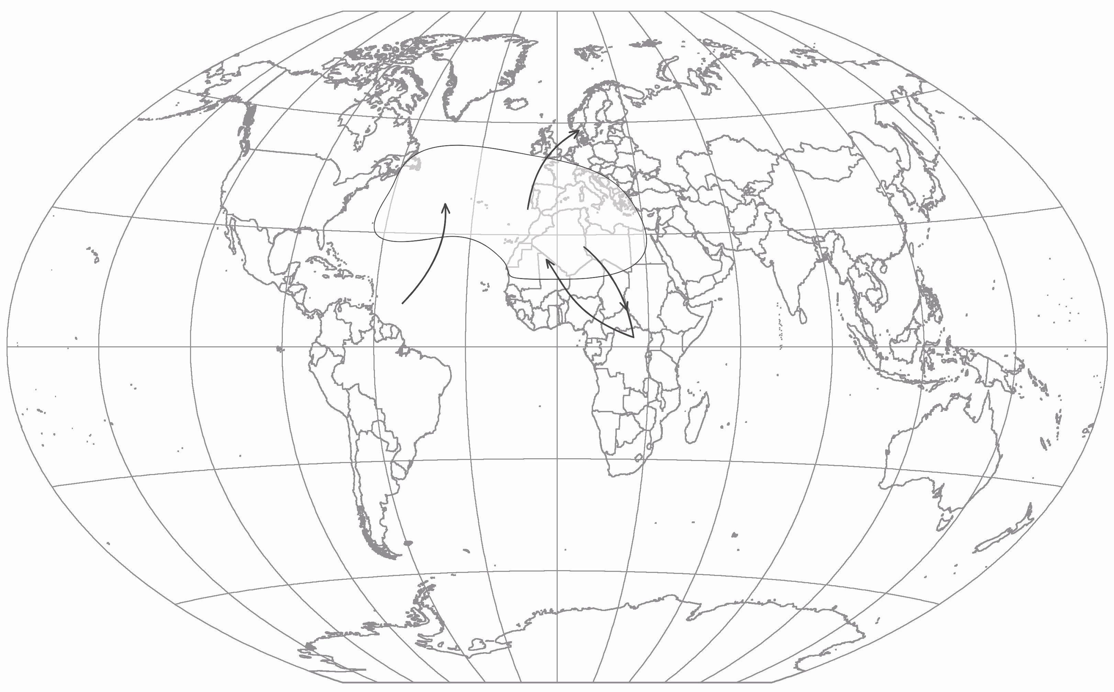
........................................................................................................................................
........................................................................................................................................
E-mail:
…………………………………………………………………………………………………..
Title of presentation:
……………………………………………………………………………………………………………..
………………………………………………………………………………………………………………..
Annotation:
........................................................................................................................................
........................................................................................................................................
........................................................................................................................................
........................................................................................................................................
Technical Requirements (please, check): a) Computer + Projector; b) Projector; c) Screen, a flipchart
Please return the application by 31st August 2014 to the address:
doc. PhDr. Zlatica Zudová-Lešková, PhD.
Institute of History AS CR, v. v. i.
Prosecká 76
190 00 Praha 9, CR

or by e-mail to:
zudova@hiu.cas.cz
The organizers reserve the right to select the papers.
The conference presentation should not exceed twenty minutes. The presented papers will be printed in a separate collective monograph in an extended version.
No conference fee is collected. The conference languages are Czech and English.

Important rules for processing the presentation:
Formal arrangement of the presentation is governed by the supplied specimen:

Název / Title

Name and surname

The actual presentation:
PC program Word - font Times New Roman 12; spacing 1.5; footnotes, citations according to The English Historical Review (ehr_style_guide.pdf) except for stating the complete Christian name of the author/authors (editor/editors); maximum number of pages 35 standard pages. Summary 15 lines at most.

The extended version should be submitted for printing directly at the conference, or it will not be published!

About the Author (max 6 lines):
……………………………………………………………………………………………………………………………………………………………………………………………………………………………………………………………………………………………………………………………………………………………………………………………………………………………………………………………………………….……………………….………………………………………………………………………………………………..…………………………………………………………………………………………………………………………………………………

