Resettlement and extermination of the populations - a syndrome of modern history
Call for Papers

Resettlements of populations became a well established and natural form of the victors' as well as losers' acting. In both cases, the main motive for resettlement was safeguarding and improving one's own existential conditions, although usually at the expense of another nation, a different group of people.

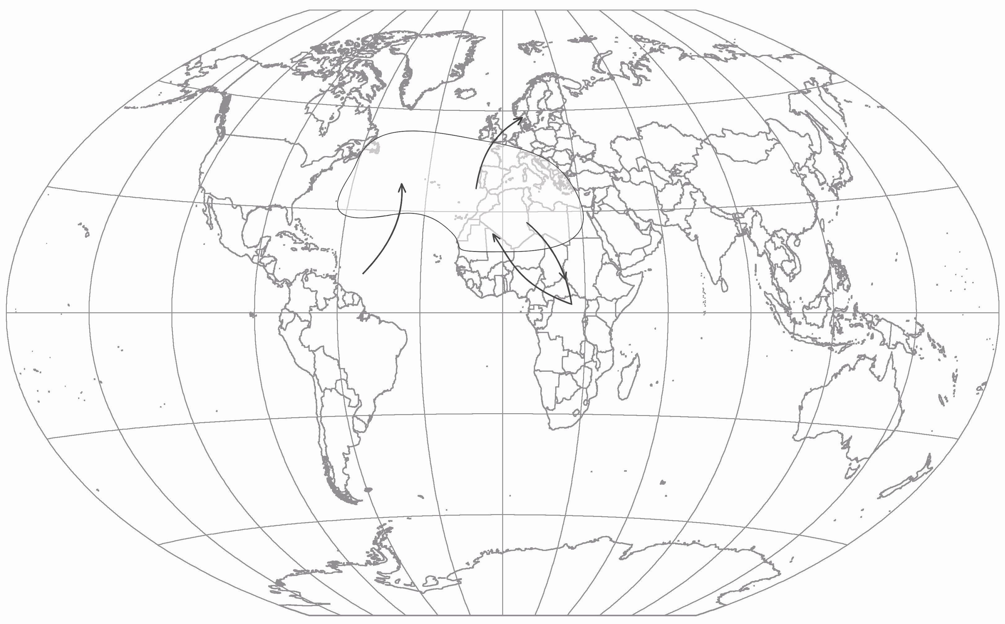
Ethnic relocations in particular were a standard feature throughout the human history during the war as well as peace, often as an outcome of peace conditions negotiated during the war. Always, however, at the cost of huge human casualties and losses.

They reached great dimensions after discovery and colonization of America and Australia, when the indigenous population was decimated during the 16th to 18th century, and also when millions of the blacks were violently relocated from Africa.

Resettlements in Europe reached gigantic proportions during the 19th century as a result of radical transformation of the societies, spread of liberalism, nationalism, socialism but also because of efforts to gain or keep vast colonies and develop capitalism. The original economical and social systems were liquidated and the man was exposed to ruthless fights, wars for money, oil or work opportunities.

The modern world produces involuntary but lawful banishment of people from their homes for economical reasons. Settlers from all European countries came to America and Australia. Asia experienced escapes of millions of Chinese and Japanese people to Southeast Asia. At the same time, there was a shift of nations on the Indian peninsula.

In the 1880s, the first wave of the Jews' aliyah to Eretz Jeisrael - the country of their origin - was recorded.

In the 20th century, relocations on the European and all other continents were deliberate, with the prospect of solving particular political and economical problems, but at the same time, they represented an impulse or consequence of escalating clashes between power interests. Forceful migration of the population was nourished by both world wars (1914-1918, 1939-1945), division of Europe into the Western and Eastern blocs and complete decolonization of Africa and Asia, but also Australia and Canada.

Relocation became an escalated form of controlling the population. New decisions manipulated the nations, groups, elites, nationals and citizens under the principle of reaching absolute political power based on dictatorship of a single party and building of fascistic, socialistic, Nazi and communist models supported by collective industrial plans, homecoming or race purity.

Violence committed on individuals, selected groups and entire nations became a natural component of resettlement for long centuries. Manipulations, conflicts and wars based on religious, power, political, ethnic or racist factors emerged as a result of xenophobia, discrimination and persecution, which were manifested by mass dimensions of repressions, genocide and holocaust - killing on a factory-production scale with a single goal - exterminate!

The decisions gave birth to escapes and forcible forms of migration: exodus, exile or emigration; the people were forced to leave the country following expulsion, banishment, deportation, loss of citizenship or as the result of political, nationalistic, racial or religious persecution and the accompanying repressions.
Objectives of the Conference
The two-day international conference will follow an open discussion on the mentioned historical facts related to two central themes of the international and intercontinental dimension. Modern world has undoubtedly experienced unprecedented forcible migrations of ethnic groups accompanied with mass violence. The conference will attempt to give an answer to the questions:
Why did it happen and what was the purpose? Were border massacres only accidental or did they serve to advance of systematic mass killing with their frequency? Do we know all facts about resettlements and annihilation of populations between the 18th and 20th century? Do we know the true reasons, forms and instruments of this action? Should we try and answer the question to what extent discussions on forceful migration of populations have been conducted so far? And how did they affect discussions on the essence of nationalism and international unity? Did they affect understanding of basic human rights in the period between adoption of the Declaration of Independence, Declaration of the Rights of Man and of the Citizen and the Universal Declaration of Human Rights, but also the Convention relating to the Status of Refugees and Declaration on the Rights of Indigenous Peoples? Is it possible to draw a lesson from the modern-time reality?
Resettlements of nations and extermination of populations in modern history is understood as a fundamental problem of migration, which has been addressed on an interdisciplinary basis at the beginning of the 21st century.
The main purpose of the conference is a historical analysis of the issues.
Resettlements of populations and annihilation of populations as an inseparable component of modern history

